**DIGITAL MARKETING**

**ASSIGNMENT-3**

**Create and design a social media advertisement poster using Canva**

|  |  |
| --- | --- |
| **NAME** | Chelsea Shalin S |
| **REG NO** | 962220106026 |
| **NM ID** | 71E62711DDC457F9CE342FE94C5C6052 |
| **TEAM ID** | NM2023TMID08872 |

**Poster:**

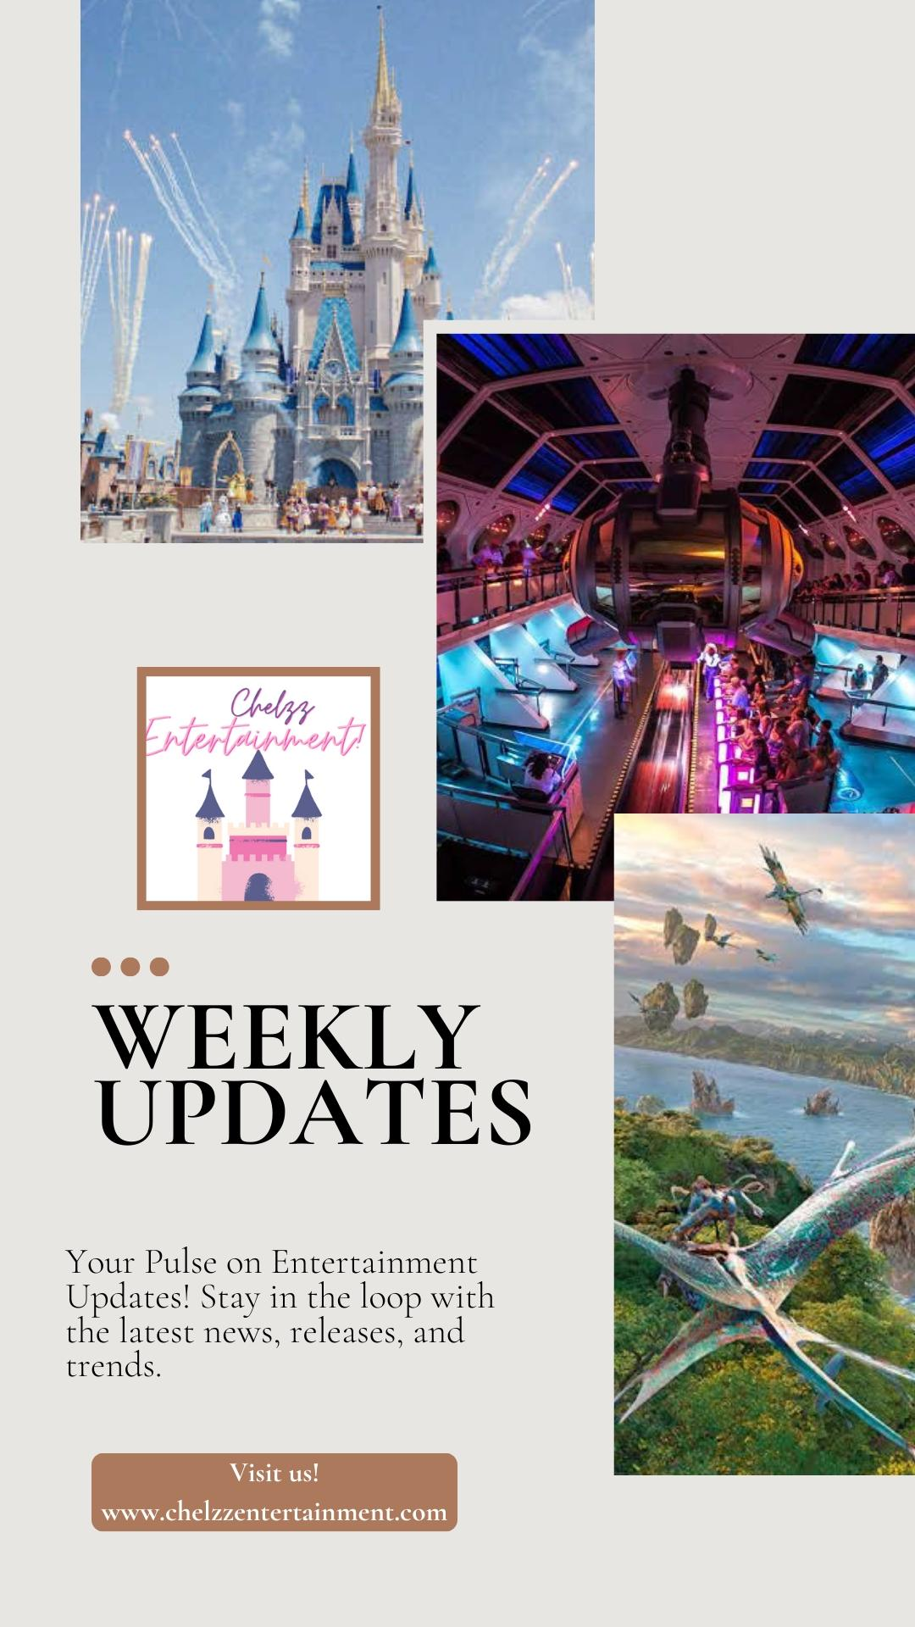

**Facebook Poster:**

